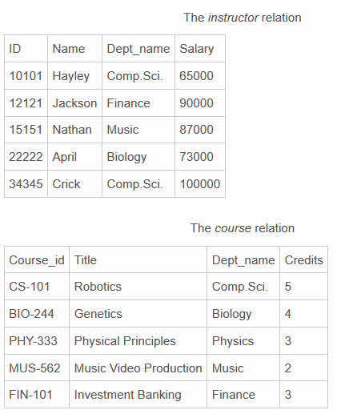

1. Which of the following command is used to display the departments of the instructor relation?  
a) Select * from instructor where Dept_name = Finance;  
b) Select * from instructor ;  
c) Select dept_name from instructor;  
d) Select dept_name for instructor where Name=Jackson;  
Answer: c  
Explanation: Only one field is necessary for the query and where clause is not needed for the selection.

2. How can we select the elements which have common Dept_name in both the relation ?  
a) Select * from instructor i , course c where i.Dept_name=c.Dept_name;  
b) Select Dept name from instructor ,Course ;  
c) Select * from instructor i , course c ;  
d) Select Dept_name from instructor where Dept_name = NULL;

Answer: a  
Explanation: Here only the common elements are displayed .

3. Select distinct Dept_name from instructor ;  
How many row(s) are displayed ?  
a) 4  
b) 3  
c) 5  
d) Error

Answer: a  
Explanation: Distinct keyword eliminates the the common Dept_name .

4. Suppose the Authority want to include a new instructor for the title Neuroscience what command should be inserted ?  
a) Insert into instructor values(12111,Emma,NeuroScience,200000);  
b) Insert into course values(12111,Introduction,NeuroScience,2);  
c)

Insert into instructor values(12111,Emma,Biology,200000);

Insert into course values(BIO-112,Introduction to Neuro Science,NeuroScience,2);

d) Insert into course values(12111,Emma,NeuroScience,200000);

Answer: c  
Explanation: The values have to be inserted into both the relations to be intact .

5. If a person all the people in Music department gets fired which of the following has to be performed on the instructor relation ?  
a) Delete Dept_name=Music in instructor;  
b) Delete from instructor where Dept_name=Music;  
c) Remove Dept_name= Music  
d) All of the mentioned

Answer: b  
Explanation: Delete from *table_name* where *condition* .

6.

SELECT DISTINCT T.name

FROM instructor AS T, instructor AS S

WHERE T.salary > S.salary AND S.dept name = ’Comp.Sci.’;

What will be displayed as the value of name for the above query?  
a) Hayley  
b) Jackson  
c) Hayley and Crick  
d) Crick

Answer: d  
Explanation: Only the greatest salary in Comp.Sci dept is selected for the query.

7.

SELECT Name

FROM instructor

WHERE salary > SOME (SELECT salary FROM instructor WHERE dept_name = 'Comp.Sci.');

How many rows are selected ?  
a) 3  
b) 4  
c) 2  
d) 1

Answer: d  
Explanation: This displays the names of instructors with salary greater than that of some (at least one) instructor in the Biology department .

8. How will you select the Names whose first letter is E ?  
a)

SELECT Name

FROM instructor

WHERE Name LIKE ’A%;

b)

SELECT Name

FROM course

WHERE Name LIKE ’A%;

c)

SELECT Dept_name

FROM instructor

WHERE Name LIKE ’A%;

d)

SELECT Name

FROM instructor

WHERE Dept_name LIKE ’A%;

Answer: a  
Explanation: % is used to indicate that some characters may appear .

9. Which function is used to find the count of distinct departments?  
a) Dist  
b) Distinct  
c) Count  
d) Count,Dist

Answer: a  
Explanation: Count (distinct ID) is the correct usage.

10. Which function is used to identify the title with Least scope?  
a) Min(Credits)  
b) Max(Credits)  
c) Min(title)  
d) Min(Salary)

Answer: a  
Explanation: Max is used to find the highest element and Min is used to find the lowest element.